Topic: Programming Concepts
2210/24/M/J/22
- A high-level programming language makes use of arithmetic, Boolean and logical operators.

State how each type of operator is used.

Give an example statement, in pseudocode, for each one.

Arithmetic .........................................................................................................................................

..........................................................................................................................................................

Example ...........................................................................................................................................

..........................................................................................................................................................

Boolean ............................................................................................................................................

..........................................................................................................................................................

Example ............................................................................................................................................

..........................................................................................................................................................

Logical ..............................................................................................................................................

..........................................................................................................................................................

Example ...........................................................................................................................................

..........................................................................................................................................................

[6]

2210/24/M/J/21
- State what is meant by the data types integer and real. Give an example of each.

Integer ..............................................................................................................................................

..........................................................................................................................................................

Example ...........................................................................................................................................

Real ..................................................................................................................................................

..........................................................................................................................................................

Example ...........................................................................................................................................

[4]

0478/24/F/M/22
2 (a) | Four descriptions and five pseudocode statements are shown.
 | Draw one line to link each description to its most appropriate pseudocode statement.
 | Not all pseudocode statements will be used.
 | Description | Pseudocode statement

a statement to count

a statement to total

a statement to start a pre-condition loop

a statement to start a post-condition loop

FOR Count 1 TO 10

Value Value + NewValue

WHILE Value > 10 DO

Value Value + 1

REPEAT

[4]

- Describe how variables and constants are used in programming.

..........................................................................................................................................................

..........................................................................................................................................................

..........................................................................................................................................................

..........................................................................................................................................................

..........................................................................................................................................................

..........................................................................................................................................................

..........................................................................................................................................................

.................................................................................................................................................... [3]

2210/23/O/N/23

2210/23/O/N/22
- Explain how variables and constants should be used when creating and running a program.

..........................................................................................................................................................

..........................................................................................................................................................

..........................................................................................................................................................

..........................................................................................................................................................

..........................................................................................................................................................

.................................................................................................................................................... [3]

2210/23/M/J/22
- State three different features of a high‑level programming language that a programmer could use to make sure that their program will be easier to understand by another programmer.
Give an example for each feature.

Feature 1 ..........................................................................................................................................

..........................................................................................................................................................

Example ...........................................................................................................................................

..........................................................................................................................................................

Feature 2 ..........................................................................................................................................

..........................................................................................................................................................

Example ...........................................................................................................................................

..........................................................................................................................................................

Feature 3 ..........................................................................................................................................

..........................................................................................................................................................

Example ...........................................................................................................................................

..........................................................................................................................................................

[6]

2210/23/M/J/21
- Tick (_{ü}) one box to show the name of the data structure used to store a collection of data of the same data type.

A Array

B Constant

C Function

D Variable

[1]

- State two features that should be included to create a maintainable program. Give a reason why each feature should be used.
  - .......................................................................................................................................................

..........................................................................................................................................................

..........................................................................................................................................................

..........................................................................................................................................................

  - .......................................................................................................................................................

..........................................................................................................................................................

..........................................................................................................................................................

..........................................................................................................................................................

[4]

0478/23/F/M/22

- Describe two types of iteration that a programmer can use whilst writing a program.

..........................................................................................................................................................

..........................................................................................................................................................

..........................................................................................................................................................

..........................................................................................................................................................

..........................................................................................................................................................

..........................................................................................................................................................

..........................................................................................................................................................

.................................................................................................................................................... [4]

- A programmer has written a program that will be maintained by another programmer.

Explain how the program can be written to make sure it can be easily maintained by the other programmer.

..........................................................................................................................................................

..........................................................................................................................................................

..........................................................................................................................................................

..........................................................................................................................................................

..........................................................................................................................................................

..........................................................................................................................................................

..........................................................................................................................................................

..........................................................................................................................................................

..........................................................................................................................................................

..........................................................................................................................................................

..........................................................................................................................................................

.................................................................................................................................................... [6]

Specimen paper 2B
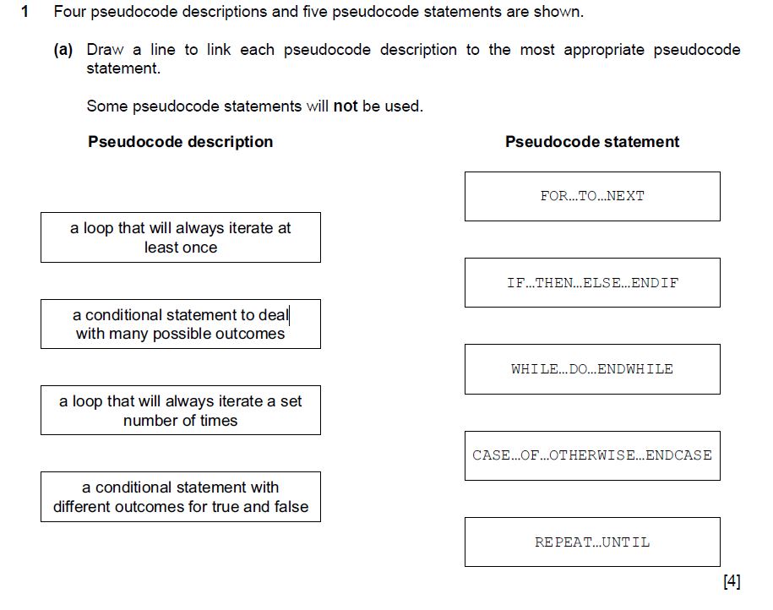
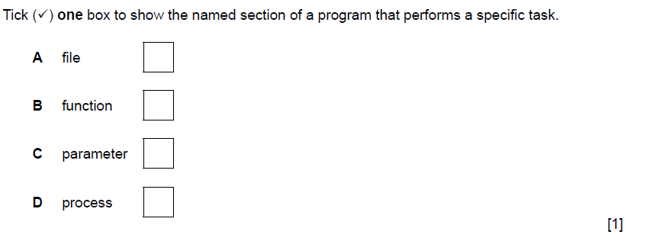
Specimen paper 2A
- Four pseudocode descriptions and five pseudocode statements are shown.

  - Draw a line to link each pseudocode description to the most appropriate pseudocode statement.

Some pseudocode statements will not be used.

Pseudocode description Pseudocode statement
IF…THEN…ELSE…ENDIF
a loop that will always iterate at least once
FOR…TO…NEXT

[4]
REPEAT…UNTIL
a conditional statement with different outcomes for true and false
CASE…OF…OTHERWISE…ENDCASE
a loop that will always iterate a set number of times

  - Using a single loop, write an algorithm in pseudocode to output 50 names that have been stored in the array, Name[]

...................................................................................................................................................

...................................................................................................................................................

...................................................................................................................................................

...................................................................................................................................................

...................................................................................................................................................

...............................................................................................................................................[3]

